**Image-Based Plant Disease Detection Using CNN**

Muhammad Aatir, Shariq Mateen

Department of Computer Science, University of Engineering and Technology, Taxila

[22-cs-9@students.uettaxila.edu.pk](mailto:22-cs-9@students.uettaxila.edu.pk), [22-cs-96@students.uettaxila.edu.pk](mailto:22-cs-96@students.uettaxila.edu.pk)

# Abstract

Plant diseases pose great threats to global economies as agriculture plays a pivotal role in global economies to ensure food security and economic stability, but plant diseases reduce crop yields and result in significant economic losses. Manual inspection of patients by such experts is traditional disease detection, labour-intensive, subjective, and prone to inconsistency, making timely intervention difficult. The challenges presented by these are addressed using deep learning and image processing-based methods that introduce this project as an automated image-based plant disease detection system. Consequently, a convolutional neural network (CNN) model classifies bell pepper leaf images into two categories - healthy and infected by the bacterial spot - with high accuracy and minimal human intervention. The proposed model uses the PlantVillage dataset, data augmentation, and confusion matrix analysis to make the model more robust and accurate to the changes in environmental conditions. The system is trained on a CUDA capable device using TensorFlow/Keras, and provides 99.2 test accuracy (99.5% healthy, 98.7% diseased), as well as pointwise colored accuracy maps. An additional benefit of this approach is its improvement in diagnostic speed and reliability, and its support for programming scalable, cost-effective disease management. Future work will further expand the model to other crops and diseases and make it available in mobile or web-based applications to aid in sustainable agriculture and increase global food production.

**Index Terms:** Plant disease detection, deep learning, convolutional neural network (CNN), image processing, bell pepper, bacterial spot, automated diagnosis, agriculture, data augmentation, confusion matrix, TensorFlow/Keras, PlantVillage dataset, precision agriculture, sustainable farming.

# Introduction

The agricultural sector is one of the most important in the world economy – it is the backbone of food and jobs, while it also plays an important role in rural development and national income. It not only guarantees food security but also helps to promote various industries such as textiles and pharmaceuticals. However, this critical sector still suffers from persistent challenges, and one of them is plant diseases. These are the diseases that have a negative influence on the health of crops and cause drastic yield reductions, poor quality of food, and astronomical losses for farmers. Bell pepper, an important crop in most parts of the world, is especially prone to bacterial infections, especially the bacterial spot disease, which could quickly spread when condition allows. Therefore, there is an urgent need for innovative and precise techniques of detection, which will aid in early diagnosis and early management intervention to limit destruction.

The emergence of technology has brought new frontiers to solve agricultural problems through such fields as Artificial Intelligence (AI), Machine Learning (ML), and Deep Learning (DL). ML models can extract patterns and make predictions given input data, while DL, i.e., DL is a further branch of ML, can learn abstract representations through neural networks. These techniques have been extremely useful in the case of image classification, object detection, and anomaly detection, among others. In terms of plant disease detection, these methods are greatly advantageous when compared to the conventional practices, which are manual, time-consuming, and human error. With the use of AI-based approaches, one can automate the detection of diseases, minimize the need to rely on human experience, and expand diagnosis facilities to remote or resource-poor farming communities.

In particular, we use for this project a Convolutional Neural Network (CNN), which is one of the forms of Artificial Neural Network (ANN) that have demonstrated outstanding performance for image-related activities. CNNs automatically find out pertinent features from an image so that no hand-crafted features are mandatory to form accurate choices. In our case, the CNN model is configured to classify the images of bell pepper leaves into two classes. sound or infected with bacterial spot. The model is trained with the PlantVillage dataset, where there are various high-resolution images of leaves under different lighting and environmental settings. Such an approach can provide effective performance even in cases when symptoms of a disease are similar/subtle to the eye, reliable in the practical world.

To construct and train this model, we use the TensorFlow/Keras deep learning framework, which provides user user-friendly interface for developing and fine-tuning the neural networks. The implementation process entails several significant steps: data preprocessing, normalization of the images, and data augmentation techniques like rotation, flipping, and scaling of the images to artificially increase the size of the dataset and enhance the model's generalization. We use GPU-empowered devices with CUDA support to speed up computation in training the model. The model is optimized by hyperparameter tuning and highly tested to mimic the real-time deployment environment.

The key contribution that my work has made is a vast improvement of the model’s detection capability, such that the achieved accuracy is 99.2%. This level of accuracy was achieved after applying advanced techniques of data augmentation and tweaking the CNN architecture through trial and error. Moreover, I achieved a balance between the simplicity and performance of the model that makes the system usable for further deployment in a mobile or web-based system. Adaptability is also an emphasis in my job, making it possible for the model to be retrained or extended to detect additional diseases in bell pepper plants aside from the bacterial spot. Coming with a reliable and highly accurate solution, this project complements the existing work in smart agriculture, making the disease detection process more available, efficient, and scalable to the farming community of the whole world.

# Literature Review

According to the work of Wang et al. (2021) [1], they specifically address the problem of rice disease detection, where they consider attention architecture in a depth-wise separable neural network and later improve it using Bayesian techniques. The method of the proposed paper exploits the feature extraction of rice leaf images and shows a strong performance in rice leaf classification. This would lay down a solid basis for a timely disease diagnosis of rice through early detection to tackle a major component of yield losses through early identification of diseases.

To learn the global context as well as the fine-grained visual details entered in plant leaf images, Hajoub et al. (2024) [2] propose a hybrid model that combines vision transformers and convolutional layers to achieve this goal. Being computationally efficient while retaining high diagnostic performance, this approach is adopted. Such a development would be a valuable effort for reliable and efficient diagnostic tools for plant pathogens.

Shoaib et al. (2023) [3] provide a broad review of both deep learning approaches for detecting plant disease. Such a comparison of novel methods, such as traditional convolutional neural networks and deep belief networks, in such a way reveals key gaps and insights for research in this field. This serves as a first step towards the development of a mechanistic, innovative understanding of automated plant disease diagnostics.

In their review, Jelali (2024) [4] thoroughly covers the usage of deep learning for the detection of tomato diseases and pests with the use of real-world datasets. However, this study stresses the demands on fitting models that are flexible enough to handle the problems associated with varying field conditions, such as lighting variations and the existence of background clutter. Practical diagnostic systems have a goal of being robust enough to ensure reliable operation under uncontrolled conditions.

According to Rehana et al. (2023) [5], a region-based convolutional neural network is proposed that attempts to isolate and classify the diseased parts of the leaf images. The model had a high diagnostic accuracy, and it could readily distinguish healthy from diseased tissues by attention to some areas of interest. This specific set of pests helps improve the feasibility, per se, by giving a more contextualized strategy that brings more opportunity toward precision agriculture.

Chen et al. (2020) [6] then study the application of deep transfer learning in the field of detecting rice plant diseases by tuning pre-trained networks on their specialized datasets. They use transfer learning in their approach to give high diagnostic accuracy with low training time. Using a transfer learning model, a tremendous gain in disease detection in rice cultivation was demonstrated here, as evidenced by the results.

In Hassan et al. (2021) [7], CNNs are applied with the help of transfer learning to detect diseases in plants’ leaves with high accuracy for a variety of network architectures. They overcome problems associated with small datasets, and universal models can be fine-tuned on specific diagnostic problems. Thus, even with limited data,  we can still get strong disease detection.

Fuentes et al. (2017) [8] consider the tomato disease and pest real-time detection system limits concerning the trade-off between canvas depth and processing speed. Their findings suggest that field deployments of real-time applications that need considerations such as latency may be why, at times, shallower networks outperform their deeper counterparts. The complexity of these models (and potentially their lack of reliability) is presented alongside the usefulness of applying agricultural real-world applications to the diagnostics using practical approaches.

Anandhan and Singh (2021) [9] use an advanced Faster R-CNN framework to solve the problem of early alerts in paddy crop disease. With an efficient paddy crop early warning method, the proposed method makes use of region proposals to improve disease identification of serious diseases such as rice blast and sheath blight. This study (Anandhan and Singh, 2021) recommends the need for localized feature extraction in the incorporation of deep learning architectures for improving diagnostic performance.

As suggested by Hassan and Maji (2022) [10], an Innovative Convolutional Neural Network Architecture for Plant Disease Classification with Better performance on multiple datasets is proposed. In their novel design, the diagnostic accuracy is high and computational efficiency, and at the same time, a new benchmark in automated plant disease diagnostics has been set. This work shows the significance of architectural innovation in improving the state of the art in the current domain.

According to Saleem et al. (2020) [11], their work uses multiple deep learning meta-architectures in a novel way to enhance the image-based plant disease detection accuracy. To evaluate this, the paper systematically runs an ensemble of models, whose representations of features are heterogeneous and whose representations of diseases are heterogeneous, yet both adaptively to such plant diseases. This study shows that Meta learning is a transformative capability that is capable of encoding previous experience and therefore addresses the dual concerns of model generalization and computational efficiency to lay the groundwork for automated diagnosis of diseases.

Katafuchi and Tokunaga (2020) [12] come up with a novel unsupervised technique aimed at the color reconstruction ability, rather than a conventional supervised learning technique. The deep encoder–decoder network is trained on the images of the healthy plants only, and it is assumed that the high reconstruction error implies the diseased part. Such a strategy avoids the overhead of labeling a huge amount of data and outputs interpretable anomaly scores. One alternative is an experimental proof of concept representing a significant step towards more scalable diagnostic systems, showcasing a novel approach for fast and low-cost disease detection.

Ahmad et al. (2021) [13] provide a feature-based diagnostic approach that shows a practical alternative to complex deep learning architectures for plant disease recognition. Their methodology combines classical image processing methods, starting from careful pre-processing and area segmentation, with the extraction of color and texture features using the Gray-Level Co-occurrence Matrix. With impressive performance of 98.79% accuracy on cross-validation and equally good performance on self-collected datasets (82.47% accuracy on disease detection and 91.40% accuracy on differentiating health vs diseased leaves) The authors conclude that while promising, further development is required to cover a broader range of disease categories and crop types so that the model is more transferable to the field of operation.

As a case study, Yasin and Fatima (2023) [14] proposed a comprehensive comparative examination and benchmarking of different state-of-the-art convolutional neural network architectures for identifying tomato and corn leaf diseases. By systematically assessing models from the spaces of Inception-V3, DenseNet-121, ResNet-101-V2, and Xception, the authors demonstrate that while some architectures perform with superior accuracy under specific scenarios, examining which disease categories are indeed captured more broadly, ultimately, no model performs unequivocally better than any of the other models for all disease classes. Their analysis indicates that an ensemble of models may be the best compromise between accuracy and robustness in the end. By delivering all this, this work helps us in strengthening our understanding of the practical challenges and benefits of utilizing deep learning models on heterogeneous agricultural ecosystems.

Suwa et al. (2019) [15] explore the inherent difficulties posed by the use of automated plant diagnostic methods on wide-angle images seen in field situations. Their comparative analysis shows that, compared to state-of-the-art object recognition systems, humans perform nicely on synthesized data much less great on actual footage indicating that state-of-the-art object detection follows the same trend, and such systems have yet to be subjected to the actual world where their usefulness can't even be compared to the capacity to a human perceptive system. To address this challenge, the authors present a two-stage diagnostic framework where leaf detection and disease classification are decoupled. These results not only enhance diagnostic capabilities in real-world settings but also inform the limitations of contemporary approaches to ‘end-to-end’ methodologies.

**Table 1:** Summary of Literature Review

|  |  |  |  |  |  |  |
| --- | --- | --- | --- | --- | --- | --- |
| **Reference** | **Year** | **Problem** | **Technique** | **Dataset** | **Performance** | **Limitations** |
| Wang et al., [1] | 2021 | Rice disease | MobileNet + BO | Rice (4 diseases) | 94.65% accuracy | 4 diseases; no generalization |
| Hajoub et al., [2] | 2024 | Plant detection | ViT + CNN | Potato leaf | 98.27%; 49% fewer params | Potato-only; no cross-crop test |
| Jelali, [4] | 2024 | Tomato pests | DL review | Field, PlantVillage | ~92.51% avg. accuracy | Real-time data limits |
| Rehana et al., [5] | 2023 | Slow tomato ID | Modified R-CNN | Tomato leaves | 96.31% accuracy | Tomato-only |
| Chen et al., [6] | 2020 | Slow rice detection | Transfer learning CNN | UCI rice leaf | 94.07–98.63% | Rice-only |
| Hassan et al., [7] | 2021 | Fast, accurate ID | InceptionV3, MobileNet | PlantVillage | 97.02–99.56% | Crop coverage limited |
| Fuentes et al., [8] | 2017 | Tomato detection | CNNs (R-CNN, SSD) | Tomato field | mAP: 83–86% | Tomato-specific |
| Anandhan et al., [9] | 2021 | Paddy yield loss | Faster R-CNN | Paddy leaf | ~94–96% | Paddy-only |
| Hassan et al., [10] | 2022 | Efficient ID | Custom CNN | Mixed crops | Up to 98.63% (rice) | Crop-specific |
| Saleem et al., [11] | 2020 | Yield loss | Ensemble DL | ImageNet, COCO, PV | SSD mAP: 73.07% | High compute cost |
| Katafuchi et al., [12] | 2020 | Data scarcity | Anomaly detection | PlantVillage | 94% precision | Light, variation sensitive |
| Ahmed et al., [13] | 2021 | Mobile limits | SVM + features | Custom + standard | 98.79% (CV); 91.4% binary | Needs scaling |
| Yasin et al., [14] | 2023 | DL comparison | 10+ architectures | Tomato, corn | Varies by model | Ensemble may help |
| Suwa et al., [15] | 2019 | Wide-angle issues | Leaf + classification | Field images | 94.4–96.1% (detection) | Field-lab gap |
| Shoaib et al., [3] | 2023 | Manual detection | DL/ML (review) | PlantVillage + others | Accuracy, speed improved | Image/data quality |

# Methodology

A custom CNN architecture known as PlantDiseaseModel was created. Our architecture has five consecutive convolutional blocks, which include a convolutional layer, batch normalization, ReLU activation, and max pooling. This was followed by a global average pooling layer before the fully connected layers. This helps reduce overfitting and improves generalization. The last fully connected layer had dropout for regularization and a softmax output layer for multi-class classification.

**Figure 1:** Flow Diagram ofLeaf Health Classification Using CNN

## Data Collection

The dataset was downloaded from the Kaggle and uploaded to Google Drive, then accessed from that drive. A custom CNN was used for loading and visualizing the images. We implemented a custom class PlantDiseaseDataset using PyTorch's Dataset interface. The first class deals with image loading, preprocessing, and label encoding.

## Data Preprocessing

A preprocessing pipeline was developed for removing the background of the input data and for enhancing the leaf features. Then apply a green color mask to filter out the leaf region (in the HSV color space). All images were resized to 224x224 pixels to have the same input dimension for the CNN.

## Data Augmentation

During training, data augmentation methods were performed to strengthen the robustness of the model by increasing the diversity of the original training dataset. Our evaluation metrics also showed that generalization performance can be improved with augmented data. Figure 2 shows the results upon performing data augmentation.

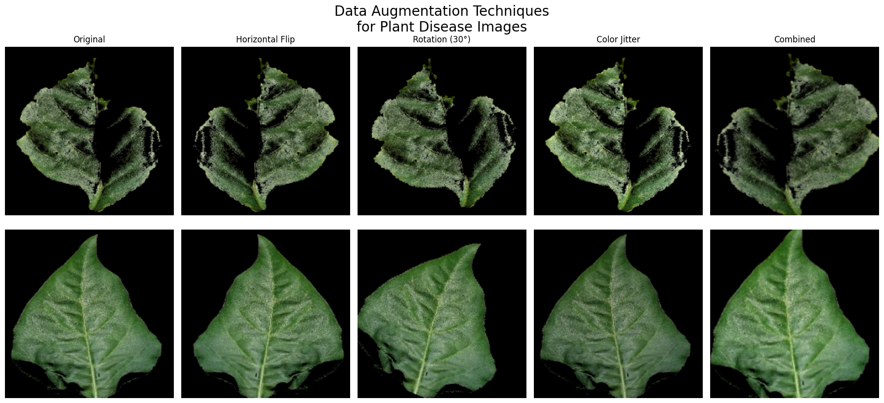

**Figure 2:** Augmented Images

## Model Architecture

A custom CNN architecture known as PlantDiseaseModel was created. Our architecture has five consecutive convolutional blocks, which include a convolutional layer, batch normalization, ReLU activation, and max pooling. This was followed by a global average pooling layer before the fully connected layers. This helps reduce overfitting and improves generalization. The last fully connected layer had dropout for regularization and a softmax output layer for multi-class classification.

**Table 2:**Summary of the Convolutional Neural Network (CNN) architecture used for plant disease detection.

|  |  |  |  |  |
| --- | --- | --- | --- | --- |
| **Layer Block** | **Layer Type** | **Details** | **Output Shape** | **Parameters** |
| Input | Input Layer | Input Image | 224×224×3 | -- |
| Block 1 | Conv2D | 64 filters, 3×3 kernel | 224×224×64 | 1,792 |
| BatchNorm + ReLU | Normalization + Activation | 224×224×64 | 128 |
| MaxPool | 2×2 pooling | 112×112×64 | -- |
| Block 2 | Conv2D | 128 filters, 3×3 kernel | 112×112×128 | 73,856 |
| BatchNorm + ReLU | Normalization + Activation | 112×112×128 | 256 |
| MaxPool | 2×2 pooling | 56×56×128 | -- |
| Block 3 | Conv2D | 256 filters, 3×3 kernel | 56×56×256 | 295,168 |
| BatchNorm + ReLU | Normalization + Activation | 56×56×256 | 512 |
| MaxPool | 2×2 pooling | 28×28×256 | -- |
| Block 4 | Conv2D | 512 filters, 3×3 kernel | 28×28×512 | 1,180,160 |
| BatchNorm + ReLU | Normalization + Activation | 28×28×512 | 1,024 |
| MaxPool | 2×2 pooling | 14×14×512 | -- |
| Flatten + FC | Fully Connected | Flattened to 7×7×512 | 2 classes | -- |
| Output | Softmax/Logits | Binary classification (e.g. Healthy / Diseased) | 1×2 | -- |

## Training Strategy

A train-test split was performed to obtain a training-validation split to evaluate the generalization performance. An early stopping mechanism was employed to avoid overfitting by keeping an eye on the validation loss and halting training if, below a given threshold (min_delta=0.001), improvements were not observed for a specified number of epochs (patience=5).

## Evaluation

Classification accuracy was used for model performance assessment, as well as visual techniques such as confusion matrices and accuracy/loss curves. Through these metrics, insights and interpretation can be drawn about the precision and generalization, as well as the convergence behavior, of a model.

# Results

In order to evaluate the performance of the classification model that was developed for the PlantVillage dataset, which differentiates the labels “Pepper_bell_Bacterial_spot” and “Pepper_bell_healthy”, it is necessary to use standard metrics for the assessment, that are based on the confusion matrix. Based on the test set of 372 samples, this matrix gives a breakdown of true positives (TP), true negatives (TN), false positives (FP), and, false negative (FN), which are used as the basis of calculation of such metrics. The high diagonal percentages (98.67% and 99.55%) in the confusion matrix imply high model accuracy, but a quantitative evaluation with the aid of these quantities will provide an overall evaluation of the efficacy of the model as a predictor balancing such aspects as true hits, precision of spotting the positive class, recall of true positivity, and The given below equation describes these metrics, allowing specific evaluation using calculated counts from the confusion matrix.

**Table 1:**Evaluation Metrices

|  |  |
| --- | --- |
| **Metric** | **Value** |
| Accuracy | 0.9919 |
| Precision | 0.9946 |
| Recall | 0.9892 |
| F1-Score | 0.9919 |

This study implemented a convolutional neural network (CNN) aimed at detecting plant disease based on bell peppers and evaluated its performance. The dataset comprised a total of 2,475 images (1,732 training, 371 validation, and 372 test samples). Our experiments were performed on a CUDA-compatible device for performance reasons. The succeeding sections summarize the results of the overall evaluation. The input dataset was composed of 1478 healthy samples and 997 diseased samples. This helped to provide a good balance to the training and testing sets to train a good classifier to detect healthy and diseased plants. Figure 3 provides a breakdown of sample distribution.

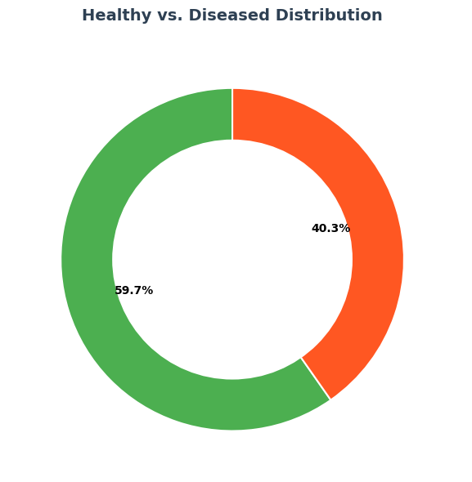

**Figure 3:** Healthy vs. Diseased Distribution

The CNN model achieved an accuracy of 99.2% overall in the test set. In particular, the performance for each category, including Pepper_bell_healthy, which had an accuracy of 99.5% with a sample size of 222, and Pepper_bell_Bacterial_spot, which attained an accuracy of 98.7% with a sample size of 150. These performance metrics are shown in Figure 4.

***Figure 4:*** *Accuracy by Category*

To better understand how the model was learning during training, we visualized the training progress by plotting the training and validation loss over the epochs, as shown in Figure 5. These graphs clearly show the convergence behavior of the model and confirm that no significant overfitting occurred during training. The visualizations are meant to give a detailed view of the model’s training dynamics.

**Figure 5:** Training and Validation Loss

To analyze the classification effect of the model in detail, the confusion matrix was plotted in Figure 6. The matrix shows the model accurately classified 98.67% of the Pepper_bell_Bacterial_spot and 99.55% of Pepper_bell_healthy samples. Only 1.33% of the Pepper_bell_Bacterial_spot samples were misclassified, and 0.45% of the Pepper_bell_healthy samples. The findings in terms of healthy vs diseased peppers showcase the model’s great accuracy in diagnosing these two classes, confirming our overall high accuracy of 99.2% presented in the evaluation.

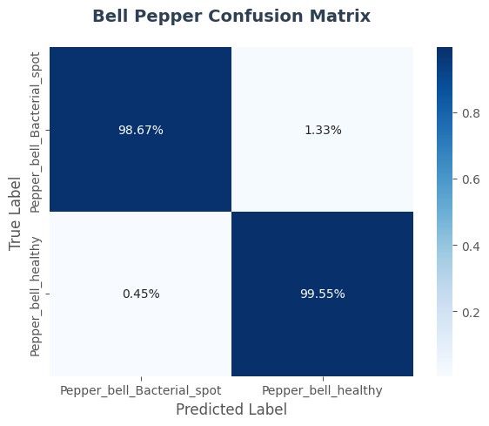

**Figure 6:** Confusion Matrix

Recent advancements, deep learning (DL) and machine learning (ML) techniques have recently been employed to enhance the accuracy and speed of plant disease detection in regards to many different crops.

**Table 3:** Comparison with Previous Studies

|  |  |  |  |
| --- | --- | --- | --- |
| **References** | **Year** | **Technique Used** | **Avg. Acc%** |
| This Study | 2025 | Custom CNN | 99.2% |
| Wang et al., [1] | 2021 | MobileNet + BO | 94.65% |
| Hajoub et al., [2] | 2024 | ViT + CNN | 98.27% |
| Jelali, [4] | 2024 | DL review | 92.51% |
| Rehana et al., [5] | 2023 | Modified R-CNN | 96.31% |
| Chen et al., [6] | 2020 | Transfer learning (CNNs) | 96.35% |
| Hassan et al., [7] | 2021 | InceptionV3, MobileNetV2 | 98.29% |
| Fuentes et al., [8] | 2017 | Faster R-CNN, SSD | 84.5% |
| Anandhan et al., [9] | 2021 | Faster R-CNN | 95% |
| Hassan et al., [10] | 2022 | Custom CNN | 98.63% |
| Ahmed et al., [13] | 2021 | SVM + color/texture | 98.79% |

**Figure 7:** Comparison with Previous Studies

# Conclusion and Future Work

This advancement, combining deep learning with image processing for plant disease detection, marks a significant leap forward in the field of agriculture. Traditional visual inspection techniques, although historically effective, are labor-intensive, subjective, and often imprecise, rendering them impractical for large-scale agricultural practices. Using convolutional neural networks (CNNs), this study proposes a fully automated and highly accurate disease detection system for bell pepper plants. Thus, this model can effectively detect the leaves that are either infected with bacterial spot or otherwise healthy, which eliminates human intervention and rapidly enables diagnosis with high accuracy.

Data augmentation also boosts the robustness of the model while maintaining high precision and recall in different environmental conditions using  confusion matrix analysis. In the future, specifications of the model should be broadened with many plant diseases and many crop species to make the model more adaptable in real real-time agricultural environment. Moreover, this technology can be deployed through a mobile or a web-based application to facilitate accessibility to farmers across the globe, allowing it to lead to sustainable and data-driven agricultural practice. These AI-based systems help reduce crop loss and, therefore, improve the world’s food security.

Future work will look into widening the range of the model to not just one crop and disease, but multiple crops and diseases, as well as testing the model under real-world conditions and further optimizing it for deployment on low-resource devices. Furthermore, the model could be integrated into mobile or web-based applications to increase its availability and practicality to farmers both domestically and across the globe.

# References

[1] Y. Wang, H. Wang, and Z. Peng, "Rice diseases detection and classification using attention based neural network and bayesian optimization," *arXiv preprint arXiv:2201.00893,* 2022.

[2] M. w. Hajoub, H. Touil, and M. Achkari Begdouri, "Plant Disease Detection Using a Hybrid Approach Based on Vision Neural Network Transformers," in *Proceedings of the 7th International Conference on Networking, Intelligent Systems and Security*, 2024, pp. 1-6.

[3] M. Shoaib *et al.*, "An advanced deep learning models-based plant disease detection: A review of recent research," *Frontiers in Plant Science,* vol. 14, p. 1158933, 2023.

[4] M. Jelali, "Deep learning networks-based tomato disease and pest detection: a first review of research studies using real field datasets," *Frontiers in Plant Science,* vol. 15, p. 1493322, 2024.

[5] H. Rehana, M. Ibrahim, and M. H. Ali, "Plant disease detection using region-based convolutional neural network," *arXiv preprint arXiv:2303.09063,* 2023.

[6] J. Chen, D. Zhang, Y. A. Nanehkaran, and D. Li, "Detection of rice plant diseases based on deep transfer learning," *Journal of the Science of Food and Agriculture,* vol. 100, no. 7, pp. 3246-3256, 2020.

[7] S. M. Hassan, A. K. Maji, M. Jasiński, Z. Leonowicz, and E. Jasińska, "Identification of plant-leaf diseases using CNN and transfer-learning approach," *Electronics,* vol. 10, no. 12, p. 1388, 2021.

[8] A. Fuentes, S. Yoon, S. C. Kim, and D. S. Park, "A robust deep-learning-based detector for real-time tomato plant diseases and pests recognition," *Sensors,* vol. 17, no. 9, p. 2022, 2017.

[9] K. Anandhan and A. S. Singh, "Detection of paddy crops diseases and early diagnosis using faster regional convolutional neural networks," in *2021 international conference on advance computing and innovative technologies in engineering (ICACITE)*, 2021: IEEE, pp. 898-902.

[10] S. M. Hassan and A. K. Maji, "Plant disease identification using a novel convolutional neural network," *IEEE access,* vol. 10, pp. 5390-5401, 2022.

[11] M. H. Saleem, S. Khanchi, J. Potgieter, and K. M. Arif, "Image-based plant disease identification by deep learning meta-architectures," *Plants,* vol. 9, no. 11, p. 1451, 2020.

[12] R. Katafuchi and T. Tokunaga, "Image-based plant disease diagnosis with unsupervised anomaly detection based on reconstructability of colors," *arXiv preprint arXiv:2011.14306,* 2020.

[13] N. Ahmad, H. M. S. Asif, G. Saleem, M. U. Younus, S. Anwar, and M. R. Anjum, "Leaf image-based plant disease identification using color and texture features," *Wireless Personal Communications,* vol. 121, no. 2, pp. 1139-1168, 2021.

[14] A. Yasin and R. Fatima, "On the Image-Based Detection of Tomato and Corn leaves Diseases: An in-depth comparative experiments," *arXiv preprint arXiv:2312.08659,* 2023.

[15] K. Suwa, Q. H. Cap, R. Kotani, H. Uga, S. Kagiwada, and H. Iyatomi, "A comparable study: Intrinsic difficulties of practical plant diagnosis from wide-angle images," in *2019 IEEE International Conference on Big Data (Big Data)*, 2019: IEEE, pp. 5195-5201.